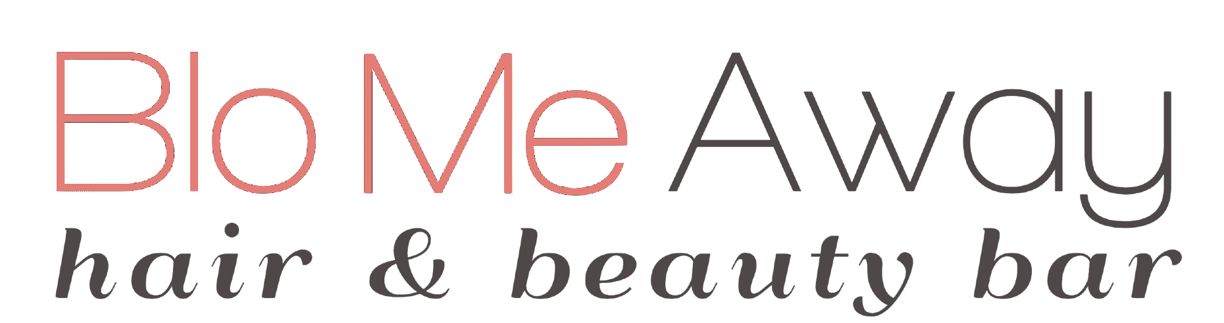

Donation Request Form
Blo Me Away participates in local auctions for local schools and charities by donating the
following to approved organizations. Please complete this form and email it to frontdesksomi@blomeawaysomi.com one week before your desired pick-up date.

2024 Blo Me Away Donation
$125 Gift Card (2 Blow Outs and a Conditioning treatment)
Kenra Gift Basket Valued at $150
Total Value $275

Date Requested
Date of Event
School/
Organization
Contact
Pick-up Date

